**编译原理第五章作业**

2154312 郑博远

1. **令文法 $G_{1}$ 为:**

$$E→E+T|T$$

$$T→T*F|F$$

$$F→\left(E\right)|i$$

**证明 $E+T*F$ 是它的一个句型，指出这个句型的所有短语，直接短语和句柄。**

**答：**

$$E$$

$$E$$

$$+$$

$$T$$

$$T$$

$$*$$

$$F$$

可以构造出如上的语法分析树，因此 $E+T*F$ 是 ${ G}_{1 }$ 的一个句型。

短语： $T*F$, $E+T*F$

直接短语： $T*F$

句柄： $T*F$

1. **考虑下面的表格结构文法 $G_{2}$:**

$$S→a|∧|(T)$$

$$T→T, S|S$$

**(2) 指出 $\left(\left(\left(a,a\right),∧,\left(a\right)\right),a\right)$ 的规范归约及每一步的句柄。根据这个规范归约,给出“移进-归约”的过程，并给出它的语法树自下而上的构造过程。**

**答：**规范规约如下（红色部分为句柄）：

|  |  |
| --- | --- |
| 句型 | 规约规则 |
|  |  |
|  |  |
|  |  |
|  |  |
|  |  |
|  |  |
|  |  |
|  |  |
|  |  |
|  |  |
|  |  |
|  |  |
|  |  |
|  |  |
|  |  |
|  |  |
|  |  |
|  |  |

|  |  |  |  |  |  |  |  |  |  |  |  |  |  |  |  |  |  |  |  |  |  |  |  |  |  |  |  |  |  |  |  |  |  |
| --- | --- | --- | --- | --- | --- | --- | --- | --- | --- | --- | --- | --- | --- | --- | --- | --- | --- | --- | --- | --- | --- | --- | --- | --- | --- | --- | --- | --- | --- | --- | --- | --- | --- |
|  |  |  |  |  |  |  |  |  |  |  |  |  |  |  |  |  |  |  |  |  |  |  |  |  |  |  |  |  |  |  |  |  |  |
| 移 | 移 | 移 | 移 | 归 | 归 | 移 | 移 | 归 | 归 | 移 | 归 | 归 | 移 | 移 | 归 | 归 | 移 | 移 | 移 | 归 | 归 | 移 | 归 | 归 | 移 | 归 | 归 | 移 | 移 | 归 | 归 | 移 | 归 |
| $$($$ | $$($$ | $$($$ | $$a$$ |  |  | $$,$$ | $$a$$ |  |  | $$)$$ |  |  | $$,$$ | $$∧$$ |  |  | $$,$$ | $$($$ | $$a$$ |  |  | $$)$$ |  |  | $$)$$ |  |  | $$,$$ | $$a$$ |  |  | $$)$$ |  |
|  |  |  |  |  |  |  |  |  |  |  |  |  |  |  |  |  |  |  |  |  |  | $$)$$ |  |  |  |  |  |  |  |  |  |  |  |
|  |  |  |  |  |  |  | $$a$$ | $$S$$ |  |  |  |  |  |  |  |  |  |  | $$a$$ | $$S$$ | $$T$$ | $$T$$ |  |  |  |  |  |  |  |  |  |  |  |
|  |  |  |  |  |  | $$,$$ | $$,$$ | $$,$$ |  | $$)$$ |  |  |  | $$∧$$ | $$S$$ |  |  | $$($$ | $$($$ | $$($$ | $$($$ | $$($$ | $$S$$ |  |  |  |  |  |  |  |  |  |  |
|  |  |  | $$a$$ | $$S$$ | $$T$$ | $$T$$ | $$T$$ | $$T$$ | $$T$$ | $$T$$ |  |  | $$,$$ | $$,$$ | $$,$$ |  | $$,$$ | $$,$$ | $$,$$ | $$,$$ | $$,$$ | $$,$$ | $$,$$ |  | $$)$$ |  |  |  | $$a$$ | $$S$$ |  |  |  |
|  |  | $$($$ | $$($$ | $$($$ | $$($$ | $$($$ | $$($$ | $$($$ | $$($$ | $$($$ | $$S$$ | $$T$$ | $$T$$ | $$T$$ | $$T$$ | $$T$$ | $$T$$ | $$T$$ | $$T$$ | $$T$$ | $$T$$ | $$T$$ | $$T$$ | $$T$$ | $$T$$ |  |  | $$,$$ | $$,$$ | $$,$$ |  | $$)$$ |  |
|  | $$($$ | $$($$ | $$($$ | $$($$ | $$($$ | $$($$ | $$($$ | $$($$ | $$($$ | $$($$ | $$($$ | $$($$ | $$($$ | $$($$ | $$($$ | $$($$ | $$($$ | $$($$ | $$($$ | $$($$ | $$($$ | $$($$ | $$($$ | $$($$ | $$($$ | $$S$$ | $$T$$ | $$T$$ | $$T$$ | $$T$$ | $$T$$ | $$T$$ |  |
| $$($$ | $$($$ | $$($$ | $$($$ | $$($$ | $$($$ | $$($$ | $$($$ | $$($$ | $$($$ | $$($$ | $$($$ | $$($$ | $$($$ | $$($$ | $$($$ | $$($$ | $$($$ | $$($$ | $$($$ | $$($$ | $$($$ | $$($$ | $$($$ | $$($$ | $$($$ | $$($$ | $$($$ | $$($$ | $$($$ | $$($$ | $$($$ | $$($$ | $$S$$ |

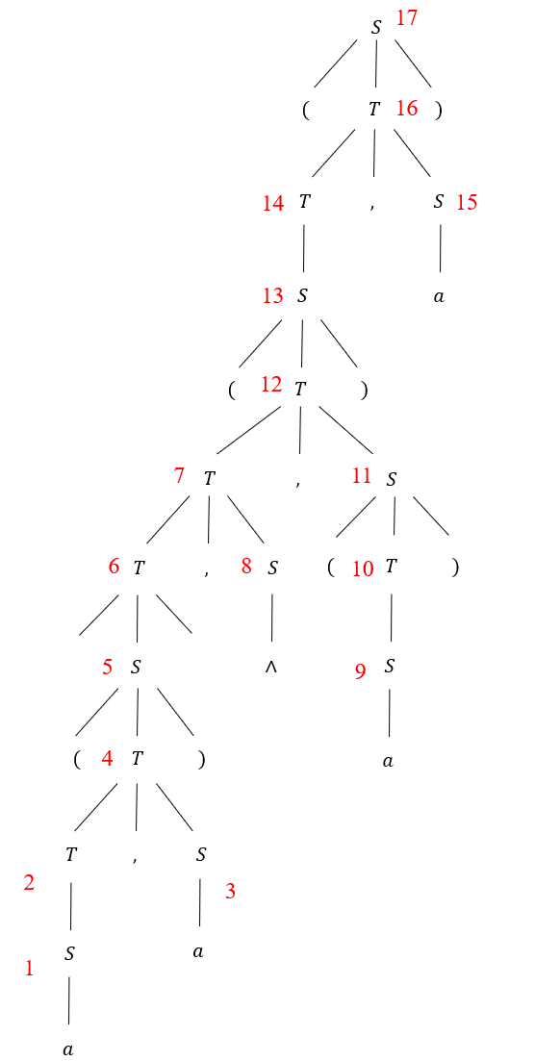语法树按照下图序号依次构造：

8

7

**3. (1)计算练习2文法 $G_{2}$ 的 FIRSTVT 和 LASTVT。**

**(2)计算 $G_{2}$ 的优先关系。 $G_{2}$ 是一个算符优先文法吗?**

**(4)给出输入 $(a,(a,a))$ 的算符优先分析过程。**

**答：**（1） FIRSTVT(T) = $\{ ,,a, ∧,( \}$

FIRSTVT(S) = $\{ a, ∧,( \}$

LASTVT(T) = $\{ ,,a, ∧,) \}$

LASTVT(S) = $\{ a,∧,) \}$

（2） 优先关系如下：

|  |  |  |  |  |  |
| --- | --- | --- | --- | --- | --- |
|  | $$,$$ | $$a$$ | $$∧$$ | $$($$ | $$)$$ |
| $$,$$ | $$⋗$$ | $$⋖$$ | $$⋖$$ | $$⋖$$ | $$⋗$$ |
| $$a$$ | $$⋗$$ |  |  |  | $$⋗$$ |
| $$∧$$ | $$⋗$$ |  |  |  | $$⋗$$ |
| $$($$ | $$⋖$$ | $$⋖$$ | $$⋖$$ | $$⋖$$ | $$≐$$ |
| $$)$$ | $$⋗$$ |  |  |  | $$⋗$$ |

首先，该文法是算符文法（任一产生式右部不含两个相继的非终结符）；

其次，该文法不包含 $ε-$ 产生式；

再者，任何终结符对都至多满足一种优先级关系。

因此， $G_{2}$ 是算符优先文法。

（4）

|  |  |  |  |
| --- | --- | --- | --- |
| 符号栈 | 关系 | 输入串 | 最左素短语 |
| $$\#$$ | $$⋖$$ | $$\left(a,\left(a,a\right)\right)\#$$ |  |
| $$\#($$ | $$⋖$$ | $$a,\left(a,a\right))\#$$ |  |
| $$\#(a$$ | $$⋗$$ | $$,\left(a,a\right))\#$$ | $$a$$ |
| $$\#(S$$ | $$⋖$$ | $$,\left(a,a\right))\#$$ |  |
| $$\#(N,$$ | $$⋖$$ | $$\left(a,a\right))\#$$ |  |
| $$\#(N,($$ | $$⋖$$ | $$a,a))\#$$ |  |
| $$\#(N,(a$$ | $$⋗$$ | $$,a))\#$$ | $$a$$ |
| $$\#(N,(N$$ | $$⋖$$ | $$,a))\#$$ |  |
| $$\#(N,(N,$$ | $$⋖$$ | $$a))\#$$ |  |
| $$\#(N,(N,a$$ | $$⋗$$ | $$))\#$$ | $$a$$ |
| $$\#(N,(N,N$$ | $$⋗$$ | $$))\#$$ | $$N,N$$ |
| $$\#(N,(N$$ | $$≐$$ | $$))\#$$ |  |
| $$\#(N,(N)$$ | $$⋗$$ | $$)\#$$ | $$(N)$$ |
| $$\#(N,N$$ | $$⋗$$ | $$)\#$$ | $$N,N$$ |
| $$\#(N$$ | $$≐$$ | $$)\#$$ |  |
| $$\#(N)$$ | $$⋗$$ | $$\#$$ | $$(N)$$ |
| $$\#N$$ | $$≐$$ | $$\#$$ |  |
| $$\#N\#$$ |  | 成功 |  |